**FLASHLIGHTS**

**AND**

**FOOTBALL**

**A BRIEF HISTORY**

**OF**

**MIDDLETON CHENEY**

**FOOTBALL**

**CLUB**

**BY**

**MARTIN R. HOWES**

**Chapter 1**

**THE EARLY DAYS**

**1884 - 1900**

The first football recorded for Middleton Cheney was against Kings Sutton Ramblers in December 1884, when Middleton won 3 - 1. Middleton's team on that day was **A. Mold**, goalkeeper, **H. Baylis** and **W. Baker**, backs, **Alf Mold, J. Cannings**, **Arthur Mold**, half backs**, Griffiths, R. Pinfold, Dudley, W. Aris** and **G.P. Smith**, forwards.

Very little is recorded from then until about 1910. It was at this time that one of the most incredible achievements is written down. Middleton had a fixture against Byfield, at Byfield, and the only means of fulfilling this was for most of the players to walk the distance. After assembling at the Red Lion, those who had no other transport walked to Byfield (10 miles) played the match and walked home. This must indicate the great enthusiasm for the game.

The village team continued after 1918 but unfortunately the teenage lads had difficulty in getting a game so they decided to form a club and team of their own. The first meeting of this new club, calling themselves the Flashlights, was held in the Jeffs hovel in Salmons Lane. It was from here that Bob Jeffs became the first secretary. Included in the gathering were Bob's brother Tom, Arthur and Charlie Merrivale, Ginger Hawkins, Willie Timms (Ucker) and **Fuggie Mold**. The first game was played in 1921.

Owing to these events, the village club had difficulty in attracting youngsters and they gradually faded out, while the Flashlights continued. The present club is now the continuation of the Flashlights. (Courtesy of Mr. Len Jerrams)

**Chapter 2**

**WW1**

**1914 – 1918**

|  |
| --- |
| In 1914, when the First World War began, football was the most popular national sport, especially with young men just the right age to fight for their country. Entire football teams joined the army together…and some died together too. Football was still played in wartime, as a way of keeping cheerful and a way of keeping fit! Many footballers joined up, and many lost their lives. |

Propaganda in use!

According to this poster, a German newspaper, the Frankfurter Zeitung, reported that “The young Britons prefer to exercise their long limbs on the football ground, rather than expose them to any sort of risk in the service of their country.”

It’s interesting to wonder how many footballers joined up as a result of this (alleged) taunt.

It’s also interesting that war was described as ‘a game.’

[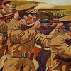](http://www.cwgc.org/glorydays/images/halloffame/ww1/recruitmentposter.jpg)

Lily Parr

At a Preston factory called ‘Dick, Kerr,’ where tramway and railway equipment was made, women had taken over the men’s work while they were away at war, so it was no surprise that they took up football too! Dick, Kerr Ladies played matches to raise money for war charities and made £600 in their first game in 1917. Within three years, over 53,000 fans were watching them play at Goodison Park.

They played abroad as well going to France and Holland, where they were greeted like superstars.

Lily Parr was the captain, and here’s a verse of a poem dedicated to her and her team:

*“They flocked in awe to wonder at  
young women in the war  
and cries of "get 'em off love"  
rang loud when they did score  
for back in nineteen seventeen  
they'd come from near and far  
to see the Dick Kerr Ladies team  
led by young Lily Parr”*

*The Khaki Final*

*Even though the First World War had started, there was still a FA Cup Final in 1915. It was between Chelsea and Sheffield United, and was held at Old Trafford, to avoid any difficulties in London. Sheffield won 3-0!*

*The match was known as The Khaki Final’ because so many of the crowd were in uniform.*

*The War Office thought it would be a good opportunity for enlistment too, so after the match, the Earl of Derby made a speech, saying, ‘It is now the duty of everyone to join with each other and play a sterner game for England.’*

*Footballers' Battalion*

*There were over 5,000 men playing professional football in 1914. Of those, 2,000 joined the military services. Some of them joined up individually, but sometimes whole teams enlisted together. Clapton (now Leyton) Orient was the first. After Fred Parker, the team captain, went into the army, about 40 players and staff followed his example.*

*They joined the 17th Battalion of the Middlesex Regiment, which became known as the "Footballers' Battalion" it had so many players in it!*

*Second-in-command, Major Frank Buckley, was wounded in the shoulder and lung in 1917. He recovered to become manager of Wolves after the war.*

*[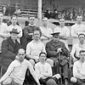](http://www.cwgc.org/glorydays/images/halloffame/ww1/footballersbattalion.jpg)*

*Christmas Day in the trenches*

*Christmas Day in 1914, became famous forever when German and British troops, who had been shelling one another hours earlier played football in No Man's Land between the trenches, shook hands and swapped souvenirs.*

*RSM Beck, of the Royal Warwickshire Regiment, put in his diary for December 24th."A quiet day. Germans shout over to us and ask us to play them at football, and also not to fire and they would do likewise. At 2am. (Christmas Day) a German band went along their trenches playing Home Sweet Home and God Save The King which sounded grand and made everyone think of home. During the night several of our fellows went over no-man's-land to the German lines and were given drink and cigarettes."*

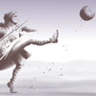

*Football boots cartoon*

*This cartoon was published in Punch Magazine in 1915.*

*[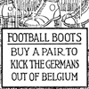](http://www.cwgc.org/glorydays/images/halloffame/ww1/footballbootscartoon.jpg)*

**Chapter 3**

**The Roaring 20s**

**1920 - 1930**

**MIDDLETON CHENEY**

**RED LION CLOSE**

**(Now Junior School Field)**

**1926**

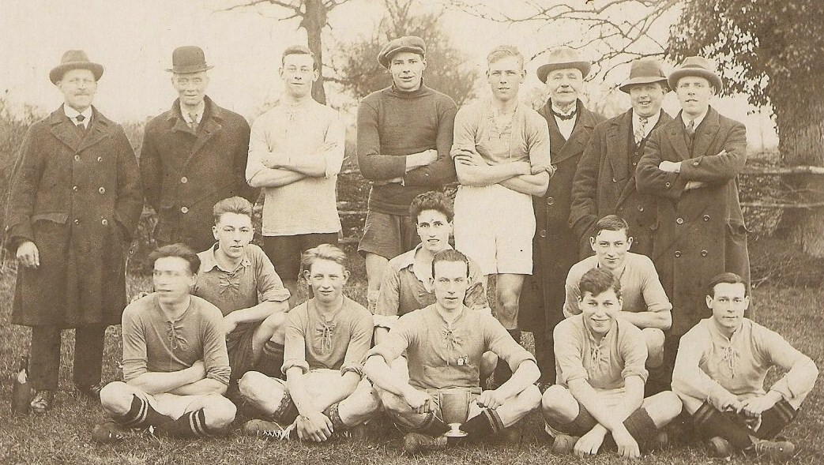

**L/R W Dumbleton, Teddy Holtom , Toby Berry , Albert Poulton , Arthur Flowers, Charles Chamberlin , Josh Timms, Albert Flowers**

**(Nobby) (GK) (Head Master) (Sec)**

**MIDDLE ROW L/R Jimmy Wilkins Alf Lines Gilbert Holtom**

**(Ricky)**

**FRONT ROW L/R Arthur Merrivale Les Aris Fred Bricknell Sam Franklin Billy Bricknell**

**1928**

**CHARITY CUP FINAL**

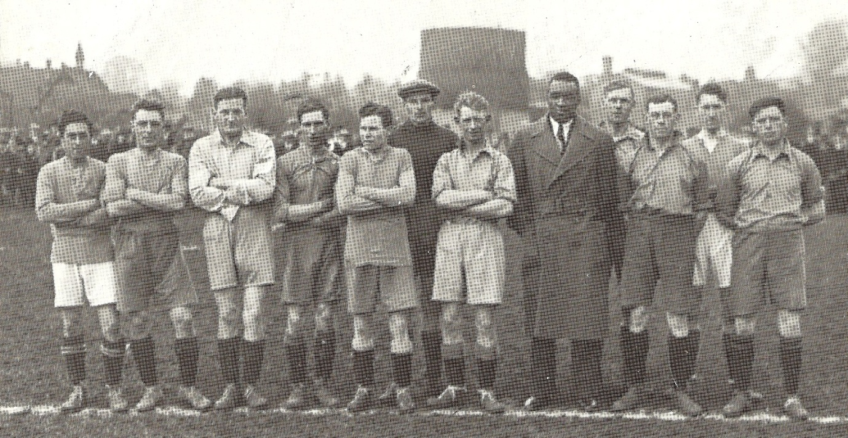

L/R Jonah. Jim Wilkins. Gerald Jarvis. Benny Barnes. Ginger Northcote. Albert Poulton. Les Aris. Larry Gains. Arthur Flowers. Toby Berry. Lee Chamberlin. Arthur Merrivale (Charlie Johnson) (Boxer kicked game off)

